

Bilkent University

Department of Computer Engineering

**CS353: Database Management Systems**

**Term Project**

Project Proposal

**Company Interview and Employment Review Platform**  
  
04.03.2019

Group 7:

* Can Özgürel / 21400476 / Section 1
* Sena Er / 21502112 / Section 1
* Hüseyin Orkun Elmas / 21501364 / Section 1
* Mehmet Mert Duman / 21600810 / Section 3

**TABLE OF CONTENTS**

**Introduction** **3**

**Project Description** **3**

Use of a Database System in Company Interview and Employment Review Platform 4

Use of Database System in our Project 4

**Requirements** **4**

Functional Requirements 4

Non-Functional Requirements 5

Security 5

Privacy 6

Data Integrity 6

Response Time 6

Capacity 6

Scalability 6

Pseudo-Requirements 6

**Limitations** **6**

**Entity Relationship Diagram** **6**

**Conclusion** **6**

**Website** **6**

# Introduction

We propose a database system for a company interview and employment review platform. This report contains the project description, requirements, limitations and Entity Relational diagram for the proposed database system.

In the project description section, we provide the aim of our project, information about status of the field, properties of our project and purpose of a database in our project.

Requirements section of the report is divided to three subsections as functional, non-functional and pseudo-requirements. In functional requirements, we list functionalities of our project. In non-functional requirements, we provide information about quality attributes of the system such as security, data integrity and integrity. In pseudo-requirements, we give information about the constraints on the technologies that will be used in the project.

In limitations section, constraints on the users is provided. After limitations section, ER diagram of our project is proposed. Finally our project website and conclusions of the report is given.

# Project Description

Company Interview and Employment Review Platform is a web-based application providing a shared platform for employees, job-seekers and companies. It aids job-seekers to discover most compatible companies within their interests, talents and expectations. System provides a platform for current and past employees to review employers and companies, and job-seekers can make a better judgement after considering these reviews. Companies can post job offers on the platform these job offers are accessible by the job-seekers. Users can also create reviews about their interview experiences about different companies, which can shape other users expectations about interview process with particular companies and help them prepare better for interviews.

By implementing this platform, we aim to enable an easier job hunting process for all the job seekers, as well as to match most suited job seekers with companies. Moreover, we plan to create an objective platform that makes companies and their employment processes more transparent and fair. A further objective of our platform is to facilitate fair pay for employees by providing a source to find out the average salaries for their position.

## Use of a Database System in Company Interview and Employment Review Platform

A company interview and employment review platform stores considerable amount of information about companies, employment reviews, interview reviews, job-offers about of the companies and also information about system’s users. New reviews and job offers can be posted frequently and for system which requires an efficient way to store change and add data. Furthermore, to increase the functionality and usability of the system it is necessary to be able to access and retrieve information based on specific attributes of a job-offer, company or review. Moreover, abilities of the users has to be constrained in ways that is mentioned in the limitations section. Finally all of this information must be maintained and fixed regularly. Thus, a database system is required for company interview and employment review platform to be efficient and effective.

## Use of Database System in our Project

We plan to use the database to store all information about the reviews, job offers and companies in our system. We will use database system to retrieve based on specific information given by the user by utilizing queries of a database. Also, we will constraint the abilities of different users (explained in section limitations) by creating constraint that will be managed by the database management system. Moreover, we will use the database to update, delete or add new information to the system. Finally our system will include past reviews and offers in a database to access later and inform users about the history of company, and create more meaningful information about companies.

# Requirements

## Functional Requirements

### Browsing

In the web platform of the system, anyone will be able to browse and acquire information about average salaries for certain locations and jobs. Companies and reviews that are written to that company and also use the search ability. Information about the mostly searched for jobs, and most wanted skills will also be available.

### Writing Reviews

Current and past employees of companies will be able to write reviews about their work and interview experiences with providing company name, salary and position information. Reviewers will also have the option to remain anonymous on each review. Users will also be able to score companies ranging from 1 to 5.

### Removal Request for Reviews

Company representatives will have the option to request removal of reviews that are written about the company they represent. These requests will be inspected by admin accounts and can be removed if they violate user agreement.

### Job-Offers

Company representatives will be able to post job offers specifying key information such as possible salary, location and required skills.

### Search

Users will be able to search for reviews, companies and job offers with specific keywords such as company name, location, salary or required skills.

### Following Companies

Users will be able to follow a number of companies they are interested in and unfollow when they stop being interested in these companies. Users will be alerted on actions that are related to the companies they follow. Furthermore, Users will be able to select for which actions they want to be notified themselves (e.g notify me when a particular company posts a job offer for a particular position or a when a review is written about a particular company).

### Saving Posts

Users will be able to save numerous posts (reviews and job-offers) and they will be able to access saved posts directly from their account so that they can easily access the posts which they are interested in reading further.

### Filtering

The result of the search functionality will be able to filtered by job types, salary range, locations and average company points.

### CV Search

Users will be able to add their CV’s to the system and opt in for CV search (note that a user that adds their CV to the system doesn’t have to opt in for CV search), and companies will be able to search for specific skills in uploaded CV’s. Furthermore, companies will be able to contact the owners of the CV’s if they want to.

## Non-Functional Requirements

### Security

All users of the system will require a username and password in order to log in. Each user’s password will be kept encrypted in our database.

### Privacy

Our database will not keep any information about the users other than the ones necessary for a reliable and consistent system. Users will not be able to access each other’s information unless the users allow their information to be viewed. Information on anonymous reviewers will not be given to any third party including the company which the review was about.

### Data Integrity

Information stored in our databases will not be shared or sold to any third parties. Furthermore, We will use frequent back-ups to prevent the loss of data during maintenance and possible failure cases.

### Response Time

Our database and website should respond to any query in no longer than a second.

### Capacity

On the initial database, at least 100,000 accounts and 10,000 reviews will be supported.

### Scalability

The system will be designed to be capable to increase in capacity as the demand increases.

## Pseudo-Requirements

We will implement the dataset and retrieve information by using SQL dataset, furthermore the users will access information through a web application.

# Limitations

* An employee will be able to write only one review about a position in a company. Furthermore, they must be currently working or worked in this position at most 5 years ago.
* An interviewee can write only a single review on a single interview process for a position with a company. They can write an interview review for each interview they had with the company. An interview is differed from the other interviews a interviewee had with the company by the position they applied for and the date on which the interview happened. The date values can be multiple since an interview can have steps that happen on different days. Furthermore, they can only write reviews about an interview process whose last date was no more than 5 years ago.
* Companies can not see CV’s of employee accounts that did not opt-in for CV search.
* A company representative account can belong to at most one company.
* A job offering can only be posted by one company representative account.
* Users can only make one post in every 10 minutes.

# Entity Relationship Diagram

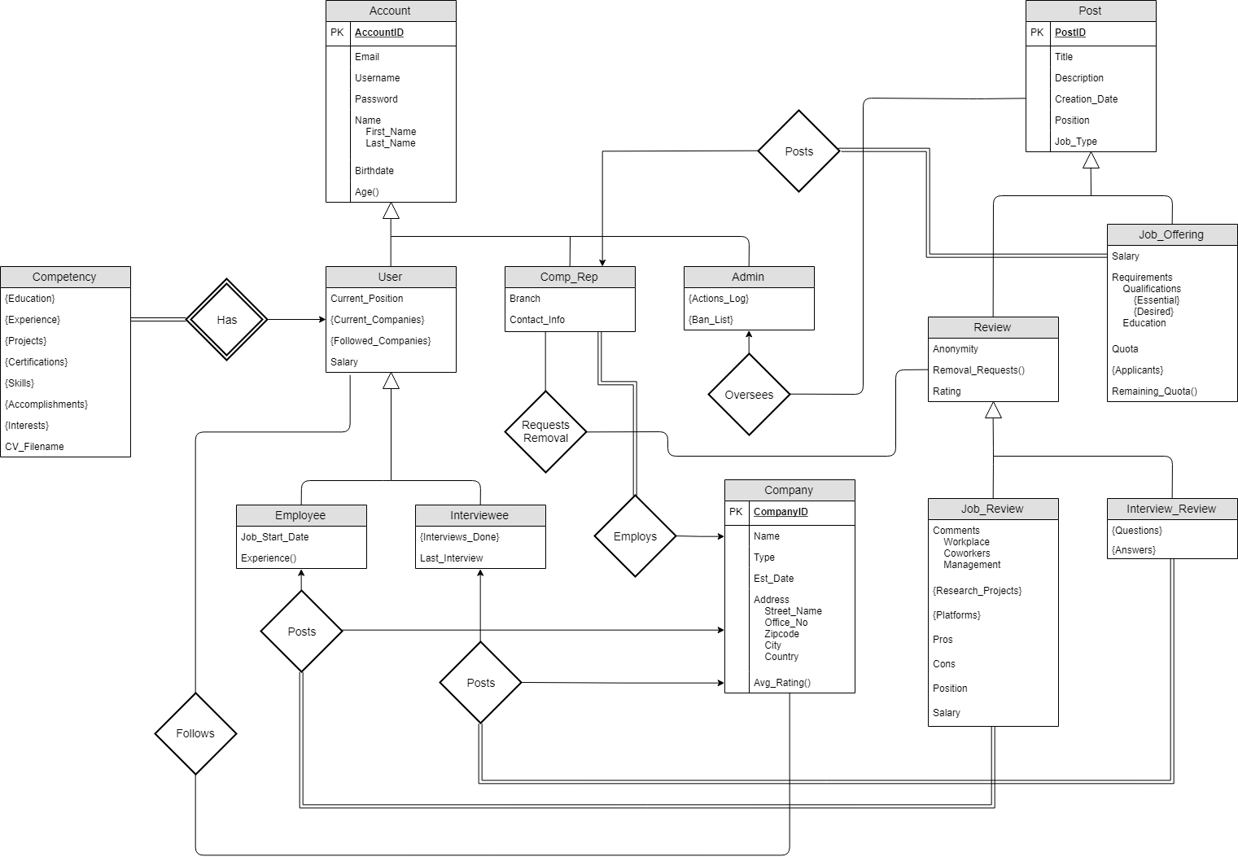

# Conclusion

Company Interview and Employment Review platform is a web-based application for browsing and posting reviews for the work or interview experiences had with a particular company. Users can also see average salaries for a position in a particular area. Additionally, companies can post job offerings or request removal of a review.

# Website

Our project website is <https://valkyrie7.github.io/DB-Project/>.